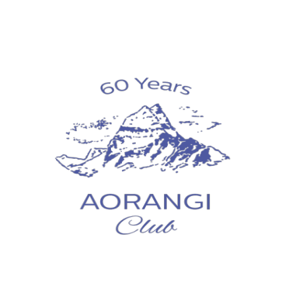
MEMBERSHIP APPLICATION INFORMATION

Thank you for your interest in joining the Aorangi Club and please refer to Application Form for completion.

The Aorangi Club was founded in 1961, on the initiative of Mrs Beatrice (Trixie) Vernon. We have a current membership of approximately 300 members. The Club was formed with the purpose of increasing members knowledge and providing an opportunity to meet and engage with like-minded women. The Club is active in inviting outstanding speakers on topics of a wide range of subjects of interest to our members.

Meetings are held from March to October, at the Ellerslie Events Centre on alternate Tuesdays from 10:30am to 12 noon. The lecture length is approximately 45 minutes, allowing time for questions followed by morning tea.

The financial year of the Aorangi Club runs from 1 October to 30 September. Subscriptions are payable in advance and are based to cover the costs of room hire and morning tea, speakers’ travel as well as the Club’s running costs. The Annual General Meeting is held in November.

The Club is run by a volunteer committee of members and participation is encouraged.

The Rules of the Club provide that a committee of no more than 12 members organise the meetings and other activities of the Club. A copy of the Rules of the Club is available from the Secretary on request.

We look forward to receiving your completed application and thank you again for your interest.

Address:

Catherine Young - Hon Secretary - Aorangi Club
PO Box 28-872 Remuera Auckland 1050
The Aorangi Club – Account 12-3030-0354-241-00
Email: aorangiclub@gmail.com

Aorangi Club Membership Application

Name: MRS/MISS/DR/MS_____________________________________________________

Preferred Name for Badge if different from above: _________________________________

Address: ___________________________________________________________________

__________________________________________________Post Code_________

Mailing address, if different from above: __________________________________________

_________________________________________________________ Post Code_________

Phone contact number: _______________________________________________________

Email address: ______________________________________________________________

Interests/career background:

___________________________________________________________________

___________________________________________________________________________

By signing this form, the applicant agrees to the acceptance of the rules of the Club and of the obligations of membership as mentioned on the previous page.

_______________________________ __________________________________
(Applicant’s name—please print) (Applicant’s signature)

Date: ___________________________ Date of birth: _______________________

Nominated by: _____________________________ ______________________
(Name—please print) (Signature)

Seconded by: ______________________________ ______________________
(Name—please print) (Signature)

APPLICATION PAYMENT PROCESS

Annual subscription is set in September each year. You will be advised of the amount due (Annual Subscription 2024 - $295.00) - 2025 TBA. Payment is due at time of application and can be made by direct debit to Aorangi Club a/c 12-3030-0354241-00. Bank deposit details - please enter your name and reference - New Member App.
Email : aorangiclub@gmail.com - Website w.aorangiclub.co.nz

